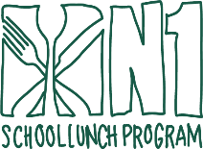


Beef Hot Dog

Turkey Sausage Pizza
Cheese Pizza

Turkey Sausage Pizza
Cheese Pizza

Hamburger

Popcorn Chicken & Tots

N1 Turkey Ham & Cheese Wrap

-Choice of 1% White/FF Chocolate milk
-Menu subject to change due to product availability
-100% Fruit Juice offered with every meal.
MAY 2026
KINDER

This institution is an equal opportunity provider

Pretzel & Cheese
Pizza EZ Take

Memorial Day

Beef Hot Dog

Chicken Corn Dog

Cheese Quesadilla

Pepperoni Pizza
Cheese Pizza

N1 Breakfast Croissan’wich

Chili Mac
Peanut Butter EZ Take

Cheeseburger

Classic Penne Alfredo

Vegetarian Chili & Tots
Yogurt EZ Take

LAST DAY OF SCHOOL

