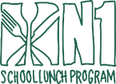
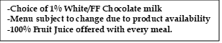

MAY 2026
K-12

This institution is an equal opportunity provider.

Chocolate Crescent (HOT)

Mantecada Muffin

Memorial Day

WG Pancakes w/
Syrup Packet

French Toast Sticks

Yogurt & Vanilla Goldfish

Turkey Sausage
Pancake Wrap

Trix Cereal
BOWL

Carrot Bun

Filled Strawberry Cream Cheese Bagels

Chicken Sausage
Pancake Sandwich

Blueberry Chex
BOWL

WG Waffles w/
Syrup Packet

Cocoa Puff Cereal
BOWL

Super Donut

Strawberry Pop Tart

Warm Biscuit &
Grape Jelly

LAST DAY OF SCHOOL

