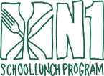
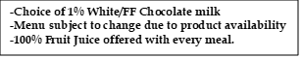

K-12
DECEMBER 2025

This institution is an equal opportunity provider.

WINTER BREAK

WINTER BREAK

Filled Strawberry Cream Cheese Bagels

Carrot Bun

Blueberry Chex
BOWL

WG Pancakes w/
Syrup Packet

French Toast Sticks

Trix Cereal
BOWL

Yogurt &
Vanilla Goldfish

Mantecada Muffin

Chocolate Crescent
(HOT)

WG Waffles w/
Syrup Packet

Cocoa Puff Cereal
BOWL

Lemon Chip Dunker

Strawberry Pop Tart

Chef’s Choice

Chicken Sausage
Pancake Sandwich

WINTER BREAK

WINTER BREAK

WINTER BREAK

WINTER BREAK

WINTER BREAK

WINTER BREAK

