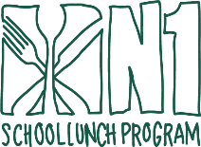

Kindergarten

THANKSGIVING
BREAK
NO SHCOOL

THANKSGIVING
BREAK
NO SCHOOL

THANKSGIVING
BREAK
NO SCHOOL

NOVEMBER 2025

-Choice of 1% White/FF Chocolate milk
-Menu subject to change due to product availability
-100% Fruit Juice offered with every meal.

This institution is an equal opportunity provider

BBQ Chicken Sandwich

Chicken Tenders

Cheeseburger

VETERANS DAY
NO SCHOOL

Pepperoni Pizza
or
Cheese Pizza

Turkey Sausage Pizza
or
Cheese Pizza

Popcorn Chicken & Tots

Chili Mac

Beef Hot Dog

N1 Breakfast
Croissan’wich

Turkey Sausage Pizza
or
Cheese Pizza

Chicken Teriyaki w/
Brown Rice

Cheesy Chicken & Tots

Classic Penne Alfredo

Vegetarian Chili & Tots

Thanksgiving Feast

Chicken Pattie Sandwich

