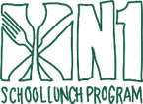
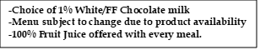

Hot M-F K-12
NOVEMBER 2025

This institution is an equal opportunity provider.

Apple Strudel
(HOT)

WG Pancakes w/
Syrup Packet

THANKSGIVING
BREAK
NO SCHOOL

WG Waffles w/
Syrup Packet

VETERANS DAY
NO SCHOOL

Strawberry Pop Tart

Filled Strawberry Cream Cheese Bagels

Carrot Bun

Blueberry Chex
BOWL

WG Pancakes w/
Syrup Packet

Chicken Sausage
Pancake Sandwich

Mini Glazed Donuts

Chocolate Chip
Banana Round

Cinnamon Toast
Crunch Cereal BOWL

Lemon Chip Dunker

Turkey Sausage
Pancake Wrap

Blueberry Snack
N’ Waffle

THANKSGIVING
BREAK
NO SCHOOL

Honey Cheerios
Cereal BOWL

Mini Cinnis
(HOT)

