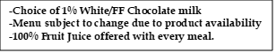
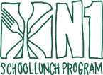

Hot M-F K-12
APRIL 2025

This institution is an equal opportunity provider.

Super Donut

Carrot Bun

NO SCHOOL
FAMILY DAY

NO SCHOOL
FAMILY DAY

Trix Yogurt &
Vanilla Goldfish

Blueberry Chex
BOWL

N1 Turkey & Cheese
Breakfast Sandwich

Apple Cinnamon
Round

Strawberry
Nutri-Grain Bar

Honey Cheerios
BOWL

Cocoa Puff Cereal
BOWL

Cinnamon Bun

WG Pancakes

French Toast

Filled Strawberry Cream Cheese Bagels

Chocolate Crescent
(HOT)

Chocolate Chip
Banana Round

Cinnamon Toast Crunch
Cereal BOWL

Blueberry
Snack N’ Waffle

Chocolate Crescent
(HOT)

Trix Cereal
BOWL

Mini Cinnis
(HOT)

