Item | Color options | Cut Options | Permitted Purchase Location
School Polo with Crest | Navy Blue or Hunter Green Polo (K-8) | Short-Sleeve or Long Sleeve | Dennis Uniform ONLY
Oxford with Crest | White or Light Blue Oxford (9-12th) | Short-Sleeve or Long Sleeve | Dennis Uniform ONLY
Sweater | Navy Blue V-Neck Cardigan (K-12)  Navy Blue 1/4 Zip Pullover (K-12)  Navy Blue Long Sleeve V-Neck (6-11)  School Blazer (11-12 ONLY) | X | Dennis Uniform ONLY
Shorts/Pants | Khaki | Slacks-Style, straight fit without extra pockets  (No cargo shorts/pants or colored jean pants) | Local Stores  Dennis Uniform
Skirt* | Khaki (K-6)  Plaid (7-11th grade) | X | Local stores  Dennis Uniform
Belt** | Solid Black or Brown | X | Local Stores
Socks | Solid Black, Brown or White | X | Local Stores
Leggings/stockings | Solid Black, Brown, White, Navy or Hunter Green | X | Local Stores
Shoes | Solid Black, Brown or White (sole color must match the shoe color) | X | Local stores (e.g., Payless, DSW, Kid’s foot Locker, Walmart, Sketchers
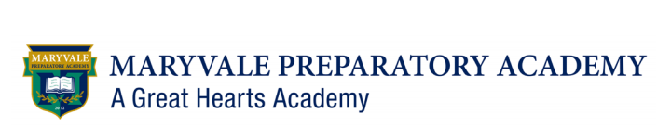
Uniform Components
The uniforms that students wear at Maryvale Prep serve to remind them that we do not derive our identity
from what we wear; rather, we derive it from what we believe, say, and do.

